Interface Control Document Version 1.0

Project Name : PSS MJ IBE Implementation

Document Name :PSS MJ IBE Implementation I-ICD_SearchWidget.doc

Document Summary
This document provides the details of how to interface with the Mihin Lanka IBE from an external website through a search widget.

Document Release Note
Document Reviewed By: Aruchunarajan Arumugam [PM, Mercator] Date: 17-Jan-2011

Document Approved By: Aruchunarajan Arumugam [PM, Mercator] Date: 17-Jan-2011

____________________________

Document Revision History
Version | Status | Update Comment | By | Date
1.0 | Approved | Reviewed and approved | Aruchunarajan Arumugam | 17-Jan-2011
0.2 | Draft | Format correction after review | Aruchunarajan Arumugam | 17-Jan-2011
0.1 | Draft | Creation of the ICD | Amarnath Kalapala | 15-Jan-2011

Distribution
Name | Title | Department
Aruchunarajan Arumugam | PM | Mercator
Thusitha | IBE PM | Mihin Lanka

Definitions & List of Abbreviations

Abbreviation | Description
IBE | Internet Booking Engine

Table of contents

1 Introduction 4
2 Interface Details 4
2.1 Interface Layout 4
2.2 Data Elements 5
2.3 List of verification & validation 6
2.4 Exception Handling 6
2.5 Performance 6
2.6 Data Exchange Format 6
3 Assumptions and Risks 7

- Introduction

This document provides the detailed description of how to interface with the Mihin Lanka IBE from an external website through a search widget. Assuming that the search widget will be available on the home page of Mihin Lanka Airlines website(www.MihinLanka.com).

- Interface Details

Interface Layout

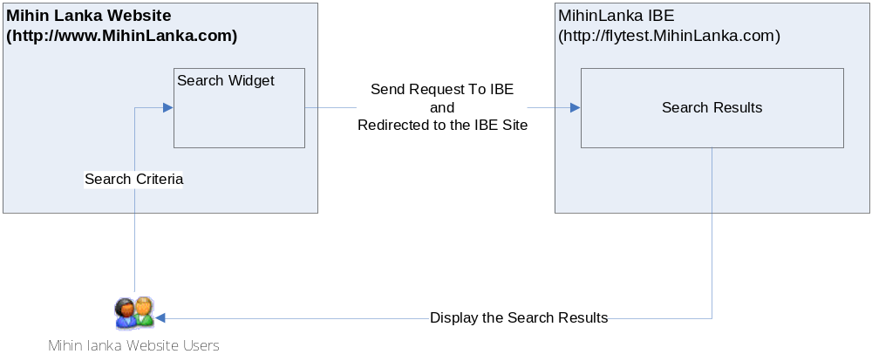

The following image shows a functional view of a Search Widget. All the important parameters and details will be provided in the section 2.2

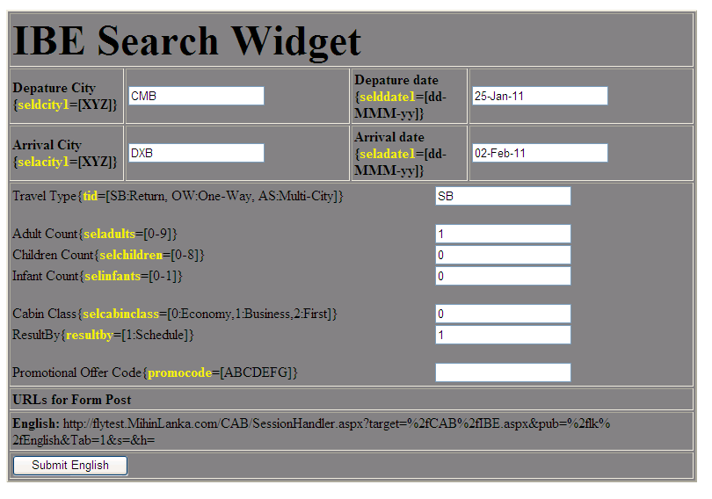

Data Elements

Sr. No. | Type | Element ID | Description
 | TextBox | seldcity1 | Depature City  Format: valid 3 digit city code  Eg: CMB
 | TextBox | selacity1 | Arrival City  Format: valid 3 digit city code  Eg: DXB
 | TextBox | selddate1 | Depature Date  Format: dd-Mmm-yy  Eg: 25-Jan-11
 | TextBox | seladate1 | Arrival Date  Format: dd-Mmm-yy  Eg: 02-Feb-11
 | TextBox | tid | Travel Type  Valid Values:  - SB for Return  - OW for One-Way  - AS for Multi-City [or Multiple Destination]  Eg: OW
 | TextBox | seladults | Adult Count  Valid Numbers: 0 to 9  Eg: 2
 | TextBox | selchildren | Children Count  Valid Numbers: 0 to 8  Eg: 1
 | TextBox | selinfants | Infant Count  Valid Numbers: 0 to 9  Special Validation: Maximum number of Infant count should not exceed the Adult Count.  Eg: 2
 | TextBox | selcabinclass | Cabin Class  Valid Options:  - 0 for Economy  Eg: 0
 | TextBox | resultby | ResultBy  Valid Options:  1 for Schedule Search
 | TextBox | promocode | Promotional Offer Code  Eg: ABCDEFG or abcdefg
 | URL | Form.Action | http://flytest.MihinLanka.com  /CAB/SessionHandler.aspx?  target=%2fCAB%2fIBE.aspx&pub  =%2flk%2fEnglish&Tab=1&s=&h=

List of verification & validation

General verifications and validations mentioned in the description section of the above Data Elements. Please refer section 2.2.

Exception Handling
Exceptions will be handled by the IBE.

Performance
Not Applicable.

Data Exchange Format

- Please refer the sample code for better understanding of the Serach Widget implementation.

- HTTP POST method should be used to redirect the user to IBE site.

- The URL and all FORM parameters with expected formats are given in the Section 2.2 Data Elements.

Note:
- Some parameters like &s=&h= are kept to be used for any security and session handling purposes that might require in the Live Environment.

- Currently the site is having only English content and can be extended to work with other languages when the content is ready.
- Assumptions and Risks

None

